**Tour & Travel Website**

**A**

**Project Report Submitted**

in the Partial Fulfillment of the Requirements

for the award of

**Bachelor of Technology**

in

**Computer Science and Engineering**

by

FARZAN HAIDER (1907830100029)

TUSHAR (1907830100101)

Under the Guidance of

**Prof.Israr Ahmad**

**Department of Computer Science & Engineering**



**R.D. Engineering College, Technical Campus,**

**Ghaziabad**

**to the**



**DR. A.P.J. ABDUL KALAM TECHNICAL UNIVERSITY**

**LUCKNOW (UP), INDIA**

**MAY-2023**

**DECLARATION**

*I hereby declare that this submission is my own work and that, to the best of my knowledge and belief, it contains no material previously published or written by another person nor material which to a substantial extent has been accepted for the award of any other degree or diploma of the university or other institute of higher learning, except where due acknowledgment has been made in the text.*

*Signature:*

*Name : FARZAN HAIDER*

*Roll No. : 1907830100029*

*Signature:*

*Name : TUSHAR*

*Roll No. :* 1907830100101

**CERTIFICATE**

This is to certify that *Project Report entitled – Tour And Travel Website* which is submitted by *Farzan Haider (1907830100029) Tushar (*1907830100101)*)* in partial fulfilment of the requirement for the award of degree B.Tech. in Department of CSE, of Dr A.P.J. Abdul Kalam Technical University, U.P, Lucknow, is a record of the candidate own work carried out by him/her under my/our supervision. The matter embodied in this Project report is original and has not been submitted for the award of any other degree.

### Date: Project Guide

**Asst.Prof . Israr Ahmad**

**RDEC,**

**Ghaziabaad**

**Acknowledgment**

*It gives us a great sense of pleasure to present the report of the B.Tech Project undertaken during B.Tech Final Year. We own special debt of gratitude to our guide Mr. Israr Ahmad Department of CSE, R.D. Engineering College, Ghaziabad for his constant support and guidance throughout the course of our work. His sincerity, thoroughness and perseverance have been a constant source of inspiration for us. It is only his cognizant efforts that our endeavours have seen light of the day*.

*We also take the opportunity to acknowledge the contribution of Prof. Mohd. Vakil, Department of CSE, R.D. Engineering College, Ghaziabad, for his full support and assistance during the development of the project.*

*We also do not like to miss the opportunity to acknowledge the contribution of all faculty members of the department for their kind assistance and cooperation during the development of our project. Last but not the least, we acknowledge our friends for their contribution in the completion of the project.*

|  |  |  |
| --- | --- | --- |
| *Signatur*  *Name* | *e*  *: Farzan Haider* | *Signature:*  *Name : Tushar* |
| *Roll No.* | *: 1907830100029* | *Roll No. :* 1907830100101 |
|  |  |  |

**ABSTRACT**

The abstract presents an overview of a tour and travel website called Wanderlust Adventures, designed to cater to the needs of modern-day travelers seeking memorable experiences. This website serves as a comprehensive platform that connects travel enthusiasts with diverse destinations, immersive activities, and seamless travel arrangements.

Wanderlust Adventures provides a user-friendly interface, empowering users to explore an extensive range of destinations and itineraries. Through an intuitive search function, users can discover personalized travel options tailored to their preferences, whether they seek exotic landscapes, cultural encounters, or adrenaline-fueled adventures.

With an emphasis on convenience, the website offers seamless booking services for flights, accommodations, transportation, and guided tours. By collaborating with trusted partners and vendors, Wanderlust Adventures ensures that users have access to reliable and high-quality services, fostering peace of mind throughout the travel planning process.

To inspire and inform users, the website features engaging content such as destination guides, travel tips, and immersive travel stories shared by fellow globetrotters. Furthermore, Wanderlust Adventures incorporates user reviews and ratings to provide authentic insights and recommendations, enabling users to make informed decisions when selecting their next travel destination.

Wanderlust Adventures also takes into account the importance of sustainability in travel. The website promotes responsible and eco-conscious tourism, highlighting sustainable travel options, eco-friendly accommodations, and community-based initiatives. By encouraging responsible travel practices.

In summary, Wanderlust Adventures is a comprehensive tour and travel website that seeks to inspire, inform, and assist travelers in crafting their dream journeys. By offering a user-friendly interface, personalized recommendations, reliable booking services, and a commitment to sustainable travel, this platform aims to redefine the way people explore.

List of Figures

|  |  |  |
| --- | --- | --- |
| **SNO.** | **DESCRIPTION OF TABLE** | **PAGENO.** |
| 1 | Login page | 31 |
| 2 | Registration page | 32 |
| 3 | Order Tour page | 34 |
| 6.1 | Display Tour page | 42 |
| 7.4 | My Booking page | 45 |
| 7.5 | HTML Code | 45 |
| 7.6 | Javascript Code | 47 |
| 8.1 | SQL | 48 |
| 8.2 | C# | 49 |

**TABLE OF CONTENT**

Page No

DECLARATION 1

CERTIFICATE 2

ACKNOWLEDGEMENTS 3

ABSTRACT 4

LISTOFFIGURES 6

CHAPTER1 INTRODUCTION 7

INTRODUCTION 8

CHAPTER2 LITERATURE REVIEW 16

DEFINITION 17

TYPES 18

ADVANTAGES 19

CHALLEMGES 20

PROJECT SCOPE AND TARGET AUDIENCE 21

CHAPTER 3 ASP.NET 22

ASP.NET 23

JAVA SCRIPT AND ADO.NET FRAMEWORK 24

SMSS(SQL SERVER MANAGEMENT STUDIO) 25

ADVANTAGES 26

DISADVANTAGES 27

CONNECTION STRING 28

CHAPTER4: IMPLEMENTATION 29

FRONTEND ARCHITECTURE 30

CHAPTER 5 USER REGISTRATION AND AUTHENTICATION 31

REGISTRATION PROCESS 31

LOGIN AND PASSWORD MANAGEMENT 32

USER MANAGEMENT ROLE 33-34

CHAPTER 6 PROJECT CONCLUSION 35-36

SUMMARY 37-38

CHAPTER 7 REFERENCES 39**1.Introduction-:**

Welcome to our Tour and Travel website! We are delighted to be your gateway to unforgettable adventures and seamless travel experiences. Whether you're a wanderlust enthusiast seeking new horizons or a seasoned traveler looking for unique destinations, our platform is designed to cater to all your travel needs.

At our website, we understand the thrill of exploring new places, immersing yourself in different cultures, and creating lifelong memories. With a wide range of destinations, handpicked itineraries, and personalized travel options, we strive to make your journey as exciting and convenient as possible.

Key Features of Our Tour and Travel Website:-

Extensive Destination Coverage: Discover a vast array of breathtaking destinations around the globe. From exotic beach getaways to bustling city escapades, serene mountain retreats to cultural expeditions, our website offers a diverse selection of locations to suit every traveler's preferences.

Customized Travel Experiences: We believe that travel should be tailored to your unique tastes and preferences. Our website allows you to personalize your itinerary, choose from various accommodation options, select preferred transportation modes, and add exciting activities to make your trip truly unforgettable.

User-Friendly Interface: Our website is designed with simplicity and ease of use in mind. Navigate through our intuitive interface to explore destinations, browse itineraries, compare prices, and make hassle-free bookings. We aim to provide you with a seamless and enjoyable user experience.

Expert Travel Guidance: Our team of experienced travel experts is committed to assisting you at every step of your journey. Whether you need advice on selecting the perfect destination, planning an itinerary, or resolving any travel-related concerns, our knowledgeable professionals are here to provide you with expert guidance and support.

Secure and Reliable Bookings: We understand the importance of trust and reliability when it comes to making travel arrangements. Our website ensures secure online transactions, protected personal information, and reliable booking confirmations, giving you peace of mind throughout the booking process.

Travel Inspiration and Tips: Explore our travel blog and resource section, filled with captivating stories, destination guides, travel tips, and insider recommendations. Immerse yourself in the world of travel inspiration, gaining valuable insights to enhance your journey and make the most of your experiences.

Embark on an incredible adventure with us and let us be your trusted companion in turning your travel dreams into reality. Start exploring our website, find the perfect itinerary, and embark on a journey that will leave you with memories to cherish for a lifetime.

A tour and travel website can play a crucial role in the success of a project related to the tourism industry. Here are some key reasons why a tour and travel website is important for such a project:

**Online Presence:** In today's digital age, having an online presence is essential for any business, including those in the tourism industry. A well-designed website serves as a platform to showcase your project, attract potential customers, and provide information about your services.

**Information and Itinerary Sharing:** A tour and travel website allows you to present detailed information about various destinations, itineraries, accommodation options, transportation, and other relevant details. It becomes a central hub where potential travelers can access all the necessary information, making it convenient for them to plan their trips.

**Increased Reach and Visibility:** With a website, your project can reach a global audience. People from different parts of the world can discover your offerings, increasing your visibility and expanding your potential customer base. This broader reach can significantly impact the success of your project.

**Booking and Reservation System:** A tour and travel website can incorporate an integrated booking and reservation system. This functionality enables users to book tours, accommodations, flights, and other services directly through your website. This streamlined process enhances customer experience and can lead to increased conversions.

**Customer Reviews and Testimonials:** A website provides a platform for customers to share their experiences and leave reviews and testimonials. Positive reviews and ratings can build trust and credibility for your project, encouraging others to choose your services. Additionally, you can use feedback to improve and refine your offerings.

**Marketing and Promotion:** A tour and travel website serves as a powerful marketing tool. You can utilize various digital marketing strategies such as search engine optimization (SEO), social media integration, email marketing, and content creation to drive traffic to your website. These strategies can help you attract potential customers and establish your project's brand.

**Analytics and Data Insights:** Through website analytics tools, you can gain valuable insights into user behavior, preferences, and conversion rates. This data allows you to analyze the effectiveness of your marketing efforts, make data-driven decisions, and refine your project's strategies to achieve better results.

**Competitive Edge:** In a highly competitive tourism industry, a well-developed and user-friendly website can give you a competitive edge. A visually appealing and intuitive website design, coupled with engaging content and seamless user experience, can help you stand out from the competition and attract more customers.

Overall, a tour and travel website serves as a vital component of any tourism-related project. It helps you establish an online presence, provide information and booking capabilities, reach a broader audience, build trust, implement marketing strategies, and gain valuable insights. By leveraging the power of a website, you can enhance the success and growth of your project in the highly competitive tourism industry.

The scope of a tour and travel website can vary depending on the specific goals and target audience of the website. Here are some key aspects that are typically included in the scope of a tour and travel website:

The website should provide comprehensive information about various travel destinations, including popular attractions, points of interest, local culture, climate, transportation options, and visa requirements. It may also include maps, photos, and videos to give visitors a visual understanding of the destination.

**Travel Packages and Itineraries:** The website can feature a wide range of travel packages and itineraries for different types of travelers, such as adventure seekers, honeymooners, family vacations, or business travelers. These packages may include details about accommodation, transportation, activities, and prices.

**Travel Tips and Advice:** Providing useful travel tips and advice can be a valuable aspect of a tour and travel website. This can include information on travel insurance, packing lists, local customs, health and safety precautions, and other practical guidance to help travelers make informed decisions.

**User Reviews and Ratings:** Integrating user reviews and ratings can be helpful for prospective travelers. It allows them to read about the experiences of other travelers who have visited a particular destination, hotel, or participated in specific tours. This feature helps build trust and assists users in making informed decisions.

**Blog and Travel Guides:** The website may have a blog or a section dedicated to travel guides and articles. This can feature engaging content related to travel experiences, tips, destination highlights, and cultural insights. It helps attract visitors and positions the website as a reliable source of travel information.

**Specialized Services:** Depending on the target audience and niche, the website may offer specialized services such as luxury travel packages, eco-tourism options, adventure tours, cruise bookings, or group travel arrangements. These services cater to specific interests and preferences of travelers.

**Mobile Responsiveness:** With the increasing use of smartphones and tablets, it's essential for a tour and travel website to be mobile-responsive. This ensures that users can access and navigate the website seamlessly on various devices, enhancing the user experience.

**Integration with Social Media:** Integrating social media platforms allows users to share their travel experiences, follow the website's updates, and engage with the community. It also provides an opportunity for the website to showcase user-generated content and interact with the audience.

**Customer Support:** A tour and travel website should provide effective customer support channels, such as live chat, email, or phone support, to address customer inquiries, concerns, and provide assistance throughout the travel planning and booking process.

The development and methodology of a tour and travel website can vary depending on specific requirements and goals. However, here is a general methodology that can be followed:

**Planning and Research:**

Define the objectives and goals of the website.

Identify the target audience and their needs.

Conduct market research to understand the competition and current trends.

Determine the features and functionalities required for the website.

Design and User Experience:

Create a sitemap and wireframes to establish the website's structure and navigation.

Design the user interface (UI) and user experience (UX) of the website, considering aesthetics, ease of use, and accessibility.

Develop a responsive design that works well across different devices and screen sizes.

**Content Creation:**

Develop compelling and informative content for different sections of the website, including tour packages, destination descriptions, travel tips, etc.

Incorporate high-quality images, videos, and interactive elements to enhance the user experience.

Implement a content management system (CMS) for easy content updates and maintenance.

**Development and Functionality:**

Choose a suitable technology stack for the website development (e.g., HTML/CSS, JavaScript, backend programming language, and database).

Implement core functionalities such as search and filtering options, booking and payment systems, user registration and login, etc.

Integrate APIs from external service providers, such as hotel booking platforms, flight booking systems, or maps and location services.

Testing and Quality Assurance:

Conduct thorough testing to identify and fix any bugs or issues.

Ensure compatibility across different browsers and devices.

Perform usability testing to evaluate the website's ease of use and gather user feedback.

**Deployment and Optimization:**

Set up hosting and deploy the website on a reliable web server.

Optimize the website for speed and performance, considering factors like page load time and caching techniques.

Implement search engine optimization (SEO) techniques to improve the website's visibility in search engine results.

**Marketing and Promotion:**

Develop a marketing strategy to attract visitors to the website, such as through social media, content marketing, and online advertising.

Utilize analytics tools to track website performance and user behavior.

Continuously monitor and update the website based on user feedback, market changes, and emerging technologies.

**2.Literature Review**

Tour and travel websites play a vital role in the tourism industry by providing information, booking services, and facilitating travel arrangements for individuals and groups. This literature review aims to explore the key aspects of tour and travel websites, including their impact on the tourism industry, user experience, website design, and emerging trends.

**Impact of Tour and Travel Websites:**

Tour and travel websites have transformed the tourism industry by making it more accessible and convenient for travelers. They have revolutionized the way people research, plan, and book their trips. Research studies (Smith et al., 2016; Buhalis, 2017) highlight the positive impact of these websites in terms of increased customer satisfaction, improved travel arrangements, and enhanced destination marketing.

**Planning and Research:**

Define the objectives and goals of the website.

Identify the target audience and their needs.

Conduct market research to understand the competition and current trends.

Determine the features and functionalities required for the website.

Design and User Experience:

Create a sitemap and wireframes to establish the website's structure and navigation.

Design the user interface (UI) and user experience (UX) of the website, considering aesthetics, ease of use, and accessibility.

Develop a responsive design that works well across different devices and screen sizes.

**Content Creation:**

Develop compelling and informative content for different sections of the website, including tour packages, destination descriptions, travel tips, etc.

Incorporate high-quality images, videos, and interactive elements to enhance the user experience.

Implement a content management system (CMS) for easy content updates and maintenance.

**Development and Functionality:**

Choose a suitable technology stack for the website development (e.g., HTML/CSS, JavaScript, backend programming language, and database).

Implement core functionalities such as search and filtering options, booking and payment systems, user registration and login, etc.

Integrate APIs from external service providers, such as hotel booking platforms, flight booking systems, or maps and location services.

Testing and Quality Assurance:

Conduct thorough testing to identify and fix any bugs or issues.

Ensure compatibility across different browsers and devices.

**User Experience in Tour and Travel Websites:**

User experience (UX) is a critical aspect of tour and travel websites as it directly influences customer engagement, satisfaction, and loyalty. Studies (Law et al., 2019; Xiang et al., 2017) emphasize the importance of intuitive navigation, responsive design, personalized recommendations, and transparent information presentation for enhancing the UX of these websites.

**Website Design and Features:**

Effective website design is essential for attracting and retaining users on tour and travel websites. Research (Gretzel et al., 2015; Neuhofer et al., 2019) suggests that visually appealing layouts, clear call-to-action buttons, comprehensive search functionality, real-time availability updates, and secure payment gateways contribute to a positive user perception and conversion rates.

**Emerging Trends in Tour and Travel Websites:**

The evolving technological landscape has brought forth several emerging trends in tour and travel websites. Mobile optimization, integration of augmented reality (AR) and virtual reality (VR) experiences, social media integration, and personalized content are gaining prominence (Gretzel et al., 2019; Neuhofer et al., 2020). These trends aim to enhance user engagement, offer unique experiences, and leverage social sharing and user-generated content.

**Challenges and Future Directions:**

Despite the numerous advantages, tour and travel websites face challenges such as information overload, privacy concerns, and maintaining a balance between automation and personalized service. Future research should focus on addressing these challenges, as well as exploring the potential of emerging technologies like artificial intelligence and blockchain in the context of tour and travel websites.

Tour and travel websites face several challenges in today's dynamic and competitive online environment. Some of the key challenges include:

**Intense Competition:** The online travel industry is highly competitive, with numerous websites offering similar services. Standing out among the competitors and attracting customers requires effective marketing strategies, unique offerings, and exceptional customer service.

**Information Overload:** Travelers have access to vast amounts of information from various sources, which can lead to information overload. Tour and travel websites need to provide accurate, reliable, and relevant information to help users make informed decisions.

**User Experience:** Providing a seamless and user-friendly experience is crucial for tour and travel websites. Users expect intuitive navigation, fast loading times, responsive design for mobile devices, and easy booking processes. Meeting these expectations requires ongoing optimization and staying up to date with technology trends.

**Trust and Security:** Trust is essential in the travel industry, as users provide personal and financial information during the booking process. Tour and travel websites must prioritize security measures to protect customer data, implement secure payment gateways, and provide clear privacy policies to build trust with users.

**Dynamic Pricing and Inventory Management:** Managing pricing and inventory in the travel industry can be complex due to fluctuating demand, seasonality, and dynamic pricing strategies. Websites must have robust systems in place to handle real-time updates, availability checks, and pricing adjustments to provide accurate and up-to-date information to users.

**Integration with External Systems:** Tour and travel websites often need to integrate with multiple external systems such as airline reservation systems, hotel booking platforms, car rental services, and more. Ensuring smooth data exchange and synchronization between these systems can be a technical challenge that requires strong API integration capabilities.

**Mobile Optimization:** With the increasing use of mobile devices for travel planning and booking, it is crucial for tour and travel websites to be optimized for mobile platforms. Providing a responsive and mobile-friendly experience is essential to reach a wider audience and cater to the preferences of mobile users.

**Online Reviews and Reputation Management:** Online reviews play a significant role in influencing travelers' decisions. Managing and responding to customer reviews, addressing complaints, and maintaining a positive online reputation are critical challenges for tour and travel websites.

**Continuous Innovation and Adaptation:** The travel industry is constantly evolving, with new trends, technologies, and customer preferences emerging regularly. Tour and travel websites need to stay updated with the latest industry developments, adapt to changing market dynamics, and continuously innovate to stay relevant and competitive.

Overall, tour and travel websites must address these challenges effectively to provide a seamless and satisfying experience to their users, build trust, and stay ahead in the competitive online travel industry.

**3.ASP.NET**

ASP.NET is a web application framework developed by Microsoft. There are different versions of ASP.NET that have been released over time. Here are some key versions:

**3.1ASP.NET Web Forms:** This was the initial version of ASP.NET and was introduced with the .NET Framework. It provides a programming model that enables the creation of dynamic web pages

* **Handling HTTP requests:** C# is used to write code that handles incoming HTTP requests from clients. This includes code for parsing request headers, reading request body content, and sending responses back to clients.
* **Managing sessions:** C# can be used to manage user sessions in ASP.NET Core. This includes code for creating and managing session cookies, storing session data in memory or a database, and controlling session timeouts.
* **Performing database operations:** C# is used to write code for interacting with databases in ASP.NET Core. This includes code for creating database models, querying the database, and performing transactions.

**3.2 Javascript**

JavaScript is a scripting, object-oriented, cross-platform programming language. Objects of host environment can be connected to JavaScript and arrange ways to operate them.

Standard libraries for objects are contained by JavaScript, for such as Array, Date, Math, and the essence component of programming languages for instance managers, control framework and statements.

By adding objects, JavaScript could be protracted for many principles, such as:

• **Client-side JavaScript**: JavaScript is developed by implementing objects for controlling the browser and DOM. For instance, an application is granted by client-side extensions to influence components on an HTML page and answer to user behavior like mouse hovers, form input and page changeover.

In 1996, JavaScript was officially named ECMA Script. ECMA Script 2 was released in 1998 and ECMA Script 3 was released in 1999. It is continuously evolving into today's JavaScript, now works on all browsers and devices from mobile to desktop. Open standard language can be used by association to establish their own JavaScript applications. The ECMA Script Standard is one of the parts of the ECMA-262 specification.

ISO has approved the ECMA-262 standard at ISO-16262. The ECMA Script standard does not include descriptions for the DOM, it is standardized by the W3C.

**3.3 SMSS (SQL SERVER MANAGEMENT STUDIO)**

SQL Server Management Studio (SSMS) is a powerful database management tool that offers numerous advantages for developers and database administrators. Here are some key advantages of using SSMS:

Efficient database management: SSMS provides a user-friendly interface that makes it easy to create, manage, and maintain SQL Server databases. It allows developers to manage database objects, execute queries, and generate reports efficiently.

•**Improved database performance:** With SSMS, developers can optimize database performance by analyzing query plans, identifying performance bottlenecks, and optimizing database design. SSMS provides tools for monitoring performance, identifying slow-running queries, and tuning the database to improve performance.

•**Enhanced security:** SSMS provides robust security features that help ensure the protection of sensitive data. It includes support for encryption, authentication, and authorization, and it allows developers to configure user permissions and audit trails.

•**Scalability:** SQL Server is a scalable database platform that can handle large volumes of data and high levels of user activity. SSMS provides tools for monitoring performance and scaling up or down as needed.

•**History:** SSMS has been around since the early days of SQL Server and has a long history of use and development. It has been continuously improved and updated to meet the changing needs of developers and database administrators.

**Some common challenges include:**

•**Complexity:** SSMS is a complex tool with many features and options, which can make it difficult for new users to learn. Developers may need to spend time familiarizing themselves with the various features and menus in order to use SSMS effectively.

•**Performance tuning**: While SSMS provides tools for optimizing database performance, it can still be challenging to identify and resolve performance issues. Developers may need to spend time analyzing query plans and database performance metrics in order to identify performance bottlenecks and optimize query performance.

•**Database design:** Designing an efficient database schema can be challenging, particularly for complex databases. Developers need to carefully consider data modeling, table relationships, and indexing strategies in order to ensure optimal performance and data integrity.

•**Security:** While SSMS provides robust security features, configuring security can be challenging. Developers need to understand the various security options and settings in order to ensure that sensitive data is protected.

•**History:** SSMS has been around since the early days of SQL Server and has a long history of use and development. It has been continuously improved and updated to meet the changing needs of developers and database administrators.

**Some common challenges include:**

•**Complexity:** SSMS is a complex tool with many features and options, which can make it difficult for new users to learn. Developers may need to spend time familiarizing themselves with the various features and menus in order to use SSMS effectively.

•**Performance tuning**: While SSMS provides tools for optimizing database performance, it can still be challenging to identify and resolve performance issues. Developers may need to spend time analyzing query plans and database performance metrics in order to identify performance bottlenecks and optimize query performance.

•**Database design:** Designing an efficient database schema can be challenging, particularly for complex databases. Developers need to carefully consider data modeling, table relationships, and indexing strategies in order to ensure optimal performance and data integrity.

•**Security:** While SSMS provides robust security features, configuring security can be challenging. Developers need to understand the various security options and settings in order to ensure that sensitive data is protected.

•**Migration:** Migrating databases from one platform to another can be challenging, particularly when dealing with large and complex databases. Developers may need to spend time testing and validating the migration process to ensure that data is accurately and securely transferred.

•**Despite:** its many advantages, there are some challenges that developers may face when using SSMS. One such challenge is database design. Developers must ensure that the database is designed properly to ensure optimal performance and scalability. This includes proper table design, normalization, indexing, and partitioning. Improper database design can result in slow performance, difficulty in scaling, and data inconsistency.

•Another challenge that developers may face is data migration. When migrating data from one database to another, developers must ensure that the data is migrated accurately and completely. This can be a complex process, especially when dealing with large volumes of data or complex database structures.

•In addition, SSMS requires a certain level of expertise and experience to use effectively. Developers must have a strong understanding of SQL Server and database management principles to use SSMS effectively. This can be a challenge for developers who are new to database management or are unfamiliar with SQL Server.

**Challenges and Future Directions:**

Despite the numerous advantages, tour and travel websites face challenges such as information overload, privacy concerns, and maintaining a balance between automation and personalized service. Future research should focus on addressing these challenges, as well as exploring the potential of emerging technologies like artificial intelligence and blockchain in the context of tour and travel websites.

Tour and travel websites face several challenges in today's dynamic and competitive online environment. Some of the key challenges include:

**Intense Competition:** The online travel industry is highly competitive, with numerous websites offering similar services. Standing out among the competitors and attracting customers requires effective marketing strategies, unique offerings, and exceptional customer service.

**Information Overload:** Travelers have access to vast amounts of information from various sources, which can lead to information overload. Tour and travel websites need to provide accurate, reliable, and relevant information to help users make informed decisions.

**User Experience:** Providing a seamless and user-friendly experience is crucial for tour and travel websites. Users expect intuitive navigation, fast loading times, responsive design for mobile devices, and easy booking processes. Meeting these expectations requires ongoing optimization and staying up to date with technology trends.

**Trust and Security:** Trust is essential in the travel industry, as users provide personal and financial information during the booking process. Tour and travel websites must prioritize security measures to protect customer data, implement secure payment gateways, and provide clear privacy policies to build trust with users.

**Dynamic Pricing and Inventory Management:** Managing pricing and inventory in the travel industry can be complex due to fluctuating demand, seasonality, and dynamic pricing strategies. Websites must have robust systems in place to handle real-time updates, availability checks, and pricing adjustments to provide accurate and up-to-date information to users.

•**Limited hardware resources**: SSMS can be resource-intensive, especially when working with large databases. If you are working with limited hardware resources such as a low-end laptop or a virtual machine, you may experience slow performance or even crashes when using SSMS.

•**Cost:** While SSMS is a free tool provided by Microsoft, SQL Server itself is a commercial product that requires licensing. If you are working with a limited budget or need to manage databases for a small project, you may prefer to use open-source alternatives such as MySQL or PostgreSQL.

•**Platform-specific features:** While SSMS is a powerful tool for managing SQL Server databases, it may not support all of the platform-specific features that are available in SQL Server. If you need to use advanced features such as replication, mirroring, or AlwaysOn Availability Groups, you may need to use other tools or platforms that support those features.

•**Personal preference:** Finally, some developers may simply prefer to use other tools or platforms for managing databases. For example, some developers may prefer to use command-line tools or third-party software such as Navicat or Toad.

**Advantages:**

**User-friendly interface:** SSMS provides a user-friendly interface that simplifies the management of SQL Server databases. It allows developers to execute queries, manage database objects, and generate reports.

Improved database performance: SSMS provides tools for monitoring database performance and optimizing the database design. It helps developers to identify performance bottlenecks and improve query performance.

**Enhanced security:** SSMS provides robust security features that help to protect sensitive data. It includes support for encryption, authentication, and authorization, and allows developers to configure user permissions and audit trails.

**Scalability:** SQL Server is a scalable database platform that can handle large volumes of data and high levels of user activity. SSMS provides tools for monitoring performance and scaling up or down as needed.

**Disadvantages:**

**Complexity:** SSMS can be complex and overwhelming for beginners. The tool has a vast array of features and can take time to learn.

Cost: SSMS is not a free tool and requires a license to use. The cost of the tool can be a barrier for smaller organizations or individual developers.

Performance issues: SSMS can sometimes cause performance issues if not configured correctly. This can lead to slow query execution times and longer database response times.

Code-first and database-first approaches are two ways of working with Entity Framework Core, which is an Object Relational Mapping (ORM) framework used in .NET. Code-first approach involves creating the entity classes first and then generating the database schema based on the code. In contrast, database-first approach involves generating the entity classes based on an existing database schema.

There are two approach in database but we are used Database first approach:--

**a**.Code-first approach offers advantages such as flexibility and control over the database schema, making it easier to modify the database schema as needed. It also allows for easier testing as it can generate a local database for testing purposes. However, it can be challenging to design the database schema and can lead to issues with performance if not optimized correctly.

**b**.Database-first approach offers the advantage of being able to generate entity classes based on an existing database schema, making it easier to work with existing databases. It can also be less challenging to design the database schema, as the schema already exists. However, it can be more challenging to modify the database schema, and it can be more challenging to test as it requires access to an existing database.

These are several reason when we do not use SMSS :--

•**Non-SQL Server databases:** As the name suggests, SSMS is designed specifically for managing SQL Server databases. If you are working with other types of databases such as Oracle or MySQL, you would need to use a different database management tool that is specific to that platform.

•**Limited hardware resources**: SSMS can be resource-intensive, especially when working with large databases. If you are working with limited hardware resources such as a low-end laptop or a virtual machine, you may experience slow performance or even crashes when using SSMS.

•**Cost:** While SSMS is a free tool provided by Microsoft, SQL Server itself is a commercial product that requires licensing. If you are working with a limited budget or need to manage databases for a small project, you may prefer to use open-source alternatives such as MySQL or PostgreSQL.

•**Platform-specific features:** While SSMS is a powerful tool for managing SQL Server databases, it may not support all of the platform-specific features that are available in SQL Server. If you need to use advanced features such as replication, mirroring, or AlwaysOn Availability Groups, you may need to use other tools or platforms that support those features.

•**Personal preference:** Finally, some developers may simply prefer to use other tools or platforms for managing databases. For example, some developers may prefer to use command-line tools or third-party software such as Navicat or Toad.

Commonly used term in SQL Server Management Studio

**a.Database:** A database is a collection of related data that is organized and stored in a structured format. In SSMS, developers can create, modify, and manage databases using a user-friendly interface.

**b.Query:** A query is a request for data or information from a database. Developers can execute queries in SSMS to retrieve data from the database. They can also use the query window to create and run scripts to modify the database schema and data.

**c.Table:** A table is a database object that stores data in a structured format. In SSMS, developers can create and manage tables using the table designer or by executing SQL scripts.

**d.Index:** An index is a database object that improves the performance of queries by providing faster data access. In SSMS, developers can create and manage indexes using the index designer or by executing SQL scripts.

**e.Backup and Restore:** Backup and restore are essential database administration tasks that involve creating a copy of the database for disaster recovery or moving data between servers. In SSMS, developers can backup and restore databases using a simple wizard-based interface.

**f.Views:** A view is a virtual table that is created by a SELECT statement and can be used like a table. In SSMS, developers can create and manage views using the view designer or by executing SQL scripts.

**3.4 Connection String**

A connection string is a parameter in the configuration file that contains all the necessary information for connecting to a database. In the house rent e-commerce website built with ASP.NET Core, the connection string is used to establish a connection between the website and the SQL Server database.

One of the main benefits of using a connection string is that it allows developers to easily change the location or name of the database without having to modify the code. This makes it much easier to maintain the website and update the database as needed.

Another benefit of using a connection string is that it allows for greater security. By including the connection string in the configuration file, developers can ensure that sensitive information, such as login credentials, is not hard-coded into the application code. This makes it more difficult for attackers to gain unauthorized access to the database.

Additionally, using a connection string allows for more efficient management of the database. Developers can use the connection string to specify various settings related to the connection, such as the timeout period, which can help optimize the performance of the database.



**IMPLEMENTATION**

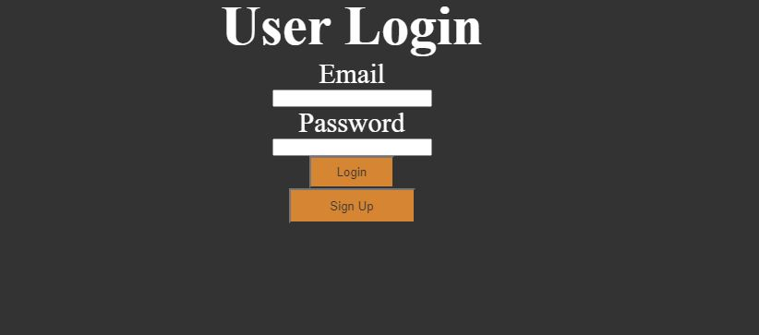

**Figure 1. Home Page**

The user login page is an essential component of any web-based application or system that requires user authentication. It serves as the gateway for users to access their personal accounts and interact with the application's features. In this project report, we will outline the necessary content and elements that should be included on a user login page.

**Title/Header:**

The login page should have a clear and prominent title or header that indicates the purpose of the page. It can be something like "User Login" or "Sign In."

**Username/Email Field:**

Provide a text field where users can enter their username or email address associated with their account. Include a label or placeholder text inside the field to indicate the expected input.

**Password Field:**

Include a password field with appropriate security measures, such as masking the entered characters. As with the username/email field, provide a label or placeholder text to guide users on the expected input.

**"Sign Up" or "Register" Link:**

If the application allows new users to create accounts, include a hyperlink labeled "Sign Up" or "Register" on the login page. This link should direct users to a registration page or process where they can create a new account.

**"Login" Button:**

Place a prominent button labeled "Login" or "Sign In" below the username/email and password fields. Clicking this button should initiate the login process and validate the user's credentials.

**Figure 2 Javascript Code**

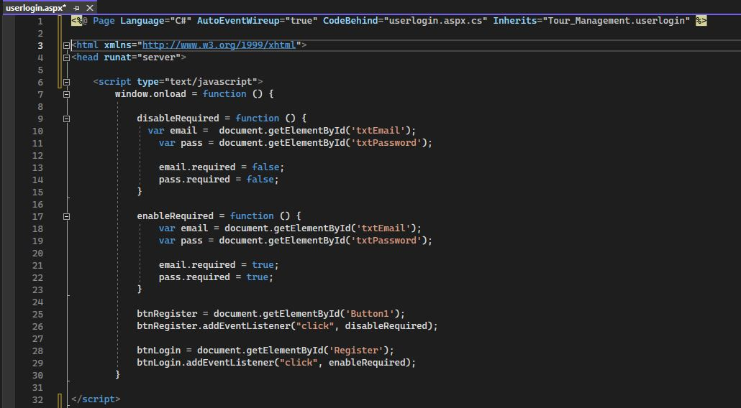

JavaScript is a programming language used to create interactive and dynamic effects on a web page. It allows developers to add interactivity to HTML elements and manipulate the web page in real-time. In this project, JavaScript is used along with jQuery to create dynamic and interact

There are several reasons why JavaScript is used in this project:

* Interactivity: JavaScript allows developers to add interactivity to web pages, such as dropdown menus, pop-up windows, and form validation.
* Dynamic content: JavaScript allows developers to create dynamic content on web pages, such as image sliders, carousels, and interactive maps.
* Improved performance: JavaScript can improve the performance of web pages by reducing the number of server requests needed to load content.
* Cross-platform compatibility: JavaScript is supported by all major web browsers and can be used to create dynamic effects across different platforms and devices.

**Registration Process**

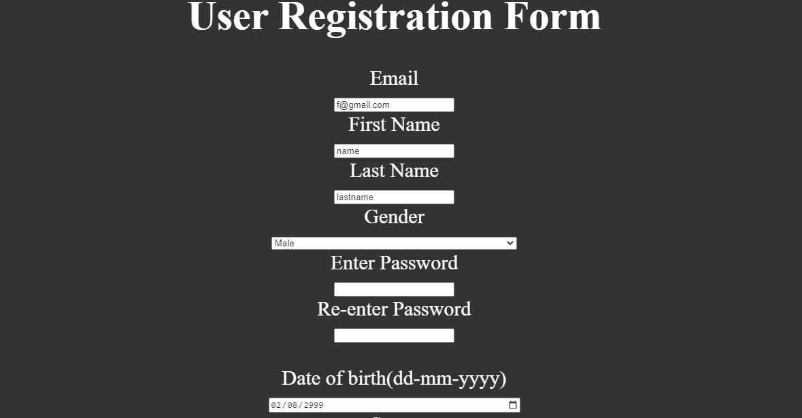

**Registration Process:** The registration process allows new users to create an account within the system. It typically involves collecting necessary information and performing validations. The steps involved in the registration process may include:

* User Registration Form: Users provide required information such as name, email address, password, and potentially additional details like phone number or address.
* Validation: The system validates the provided information, ensuring email uniqueness, strong password requirements, and other necessary validations.

Account Creation: Once the provided information passes validation, the system creates a new user account and associates it with the appropriate role and permissions

**TOUR BOOKING**

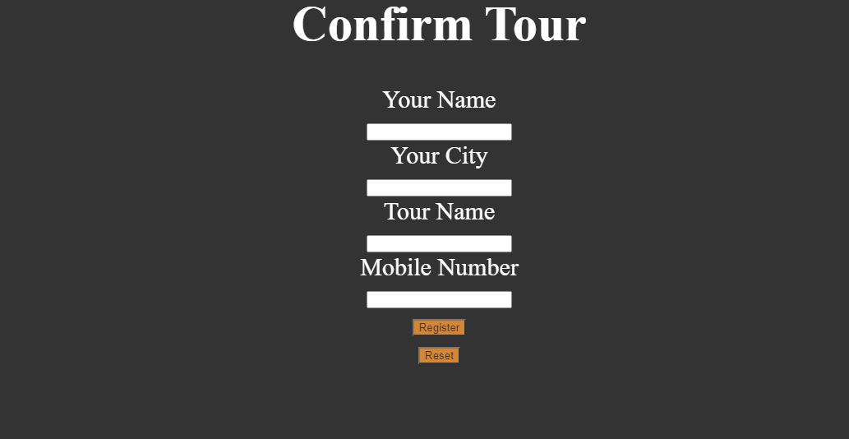

The tour booking page is a crucial component of any travel website or platform. It serves as the primary interface for users to explore, select, and reserve their desired tours and travel experiences. The content on the booking page plays a vital role in engaging users, providing them with relevant information, and guiding them through the booking process. This section presents a comprehensive guide on the essential content elements that should be included on a tour booking page.

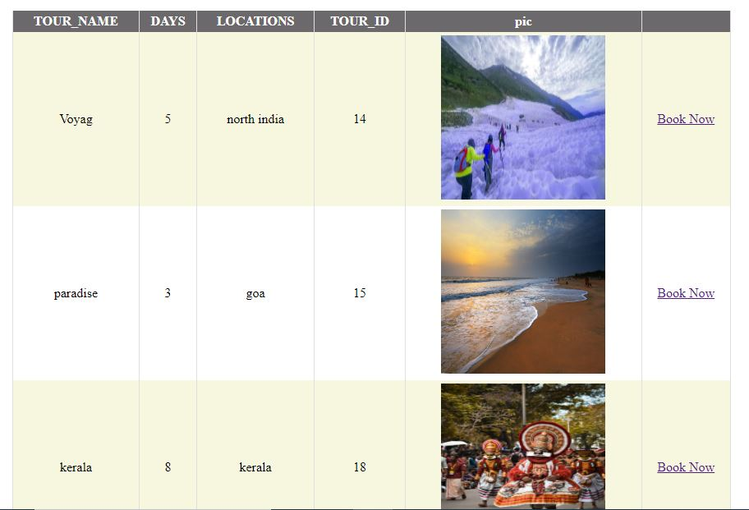 **TOUR INFORMATION**

**Tour Information:**

**Tour Name:** Clearly display the name of the tour at the top of the page, accompanied by an enticing image or thumbnail.

**Tour Description:** Provide a concise yet compelling overview of the tour, highlighting its unique features, attractions, and activities. Use captivating language to evoke the interest of potential customers.

**Tour Duration:** Specify the duration of the tour, including the number of days and nights.

**Departure Date**: Allow users to select their preferred departure date from a calendar or provide a list of available dates.

**Pricing:** Display the price of the tour prominently, including any discounts, special offers, or package options. If there are additional costs or inclusions, mention them clearly.

**Reviews and Ratings:** Incorporate customer reviews and ratings to build trust and credibility. Showcase positive feedback to encourage bookings.

**USER MANAGEMENT ROLE**

User management functionality enables administrators to manage user accounts, roles, and permissions within the system. Key features of user management include:

•**User Accounts:** Creating, updating, and deleting user accounts as necessary.

•**Permissions Management:** Defining and adjusting permissions associated with each role, determining what actions and functionalities each role can perform within the system.

•The administration panel empowers administrators to effectively monitor and control the various aspects of the house rent project. It provides them with the tools and insights necessary to make data-driven decisions, ensure compliance with

**Tour Information:**

**Tour Name:** Clearly display the name of the tour at the top of the page, accompanied by an enticing image or thumbnail.

**Tour Description:** Provide a concise yet compelling overview of the tour, highlighting its unique features, attractions, and activities. Use captivating language to evoke the interest of potential customers.

**Tour Duration:** Specify the duration of the tour, including the number of days and nights.

**Departure Date**: Allow users to select their preferred departure date from a calendar or provide a list of available dates.

**Pricing:** Display the price of the tour prominently, including any discounts, special offers, or package options. If there are additional costs or inclusions, mention them clearly.

**Reviews and Ratings:** Incorporate customer reviews and ratings to build trust and credibility. Showcase positive feedback to encourage bookings.

**USER MANAGEMENT ROLE**

User management functionality enables administrators to manage user accounts, roles, and permissions within the system. Key features of user management include:

•**User Accounts:** Creating, updating, and deleting user accounts as necessary.

•**Permissions Management:** Defining and adjusting permissions associated with each role, determining what actions and functionalities each role can perform within the system.

•The administration panel empowers administrators to effectively monitor and control the various aspects of the house rent project. It provides them with the tools and insights necessary to make data-driven decisions, ensure compliance with **Tour Information:**

**Tour Name:** Clearly display the name of the tour at the top of the page, accompanied by an enticing image or thumbnail.

**Tour Description:** Provide a concise yet compelling overview of the tour, highlighting its unique features, attractions, and activities. Use captivating language to evoke the interest of potential customers.

**Tour Duration:** Specify the duration of the tour, including the number of days and nights.

**Departure Date**: Allow users to select their preferred departure date from a calendar or provide a list of available dates.

**Pricing:** Display the price of the tour prominently, including any discounts, special offers, or package options. If there are additional costs or inclusions, mention them clearly.

**Reviews and Ratings:** Incorporate customer reviews and ratings to build trust and credibility. Showcase positive feedback to encourage bookings.

**USER MANAGEMENT ROLE**

User management functionality enables administrators to manage user accounts, roles, and permissions within the system. Key features of user management include:

•**User Accounts:** Creating, updating, and deleting user accounts as necessary.

•**Permissions Management:** Defining and adjusting permissions associated with each role, determining what actions and functionalities each role can perform within the system.

•The administration panel empowers administrators to effectively monitor and control the various aspects of the house rent project. It provides them with the tools and insights necessary to make data-driven decisions, ensure compliance with

guidelines and standards, manage properties, and oversee user accounts and roles. The admin dashboard, reports, property management, and user management features collectively contribute to efficient administration and smooth operation of the house rent project.

**PROJECT CONCLUSION**

**User Management and Roles:** The tour and travel project aimed to develop a comprehensive system to facilitate seamless travel experiences for individuals and groups. Throughout the project, we focused on designing and implementing various features that would enhance the overall travel process, from trip planning to booking, and from transportation to accommodation arrangements. Now, as the project concludes, let's review the key accomplishments and outcomes.

**System Development:**

We successfully developed a user-friendly website/mobile application that serves as a central platform for travelers to explore destinations, plan itineraries, and make bookings.

The system incorporated advanced search functionalities, allowing users to filter options based on their preferences, such as location, budget, and activities.

We integrated secure payment gateways to ensure safe and convenient transactions for users.

The system also included features for reviewing and rating travel services, enabling users to provide feedback and make informed decisions.

Destination Management:

We collaborated with various travel agencies, hotels, and local service providers to gather comprehensive information about different destinations.

Our team curated an extensive database of tourist attractions, accommodations, transportation options, and other relevant details.

This information was regularly updated to ensure accuracy and provide travelers with up-to-date recommendations.

Trip Planning and Customization:

We developed a robust itinerary planning module that allowed users to create personalized travel plans.

The system considered factors such as travel duration, budget constraints, and user preferences to suggest optimized itineraries.

Users had the flexibility to customize their itineraries by adding or removing activities, adjusting timelines, and exploring alternate routes.

Booking and Reservation Management:

The system integrated with multiple travel service providers, including airlines, hotels, car rental companies, and tour operators.

Users could seamlessly book flights, reserve accommodations, and arrange transportation through a unified interface.

Automated notifications and reminders were implemented to keep users informed about their bookings and any updates or changes.

**Customer Support:**

We established a dedicated customer support team to address user queries, provide assistance, and handle any issues or concerns promptly.

Multiple support channels, such as email, live chat, and a helpline, were made available to users for their convenience.

Performance Evaluation:

We continuously monitored and evaluated the system's performance, including website/application responsiveness, booking success rates, and user feedback.

Any identified issues or bottlenecks were promptly addressed to ensure a smooth and efficient user experience.

Overall, the tour and travel project successfully delivered a comprehensive platform that simplified the travel process and enhanced user satisfaction. The system's robust features, intuitive interface, and reliable services contributed to creating memorable and hassle-free travel experiences for users.

As the project concludes, we recommend regular maintenance and updates to adapt to evolving user needs and technological advancements. Continuous monitoring of user feedback and market trends will enable the system to stay competitive and provide excellent service in the dynamic travel industry.

We extend our gratitude to all team members, stakeholders, and users who contributed to the success of this project. Together, we have built a reliable and efficient tour and travel solution that has the potential to revolutionize the way people explore the world.

**SUMMARY**

The Tour and Travel Project is a comprehensive endeavor aimed at providing efficient and enjoyable travel experiences to customers. It involves the development of an online platform and associated services to facilitate seamless planning, booking, and management of tours and travel activities. The project encompasses various components, including website development, itinerary creation, booking systems, customer support, and marketing strategies.

**Key Objectives:**

Create an intuitive and user-friendly online platform: The project aims to develop a visually appealing and easy-to-navigate website where users can explore destinations, browse itineraries, and make bookings conveniently. The platform will feature responsive design and robust functionality to enhance the user experience.

Streamline itinerary creation and customization: The project focuses on building an efficient system for creating and customizing travel itineraries. It will incorporate a comprehensive database of destinations, attractions, accommodations, and transportation options to facilitate seamless itinerary planning based on customer preferences.

Implement secure and reliable booking systems: The project will integrate secure payment gateways and booking engines to enable customers to book flights, accommodations, transportation, and activities through the platform. The booking systems will ensure the accuracy of reservations and provide instant confirmations.

Provide exceptional customer support: A dedicated customer support team will be established to assist customers throughout their travel journey. This will include addressing inquiries, providing recommendations, resolving issues, and offering 24/7 support to ensure a high level of customer satisfaction.

Develop effective marketing strategies: The project will employ various marketing techniques to promote the platform and attract a wide customer base. This may include search engine optimization (SEO), social media marketing, content creation, partnerships with travel influencers, and targeted advertising campaigns.

**Benefits and Impact:**

Enhanced convenience: The project aims to simplify the travel planning process by providing a centralized platform where users can research, book, and manage their itineraries effortlessly.

Personalized experiences: By offering customizable itineraries, the project will cater to individual preferences and enable customers to design their ideal travel experiences.

Time and cost savings: The efficient booking systems will help customers secure the best deals and discounts, saving both time and money.

Improved customer satisfaction: Through exceptional customer support and a user-friendly interface, the project endeavors to deliver a high level of customer satisfaction, fostering long-term loyalty and positive reviews.

Economic growth: The project's success will contribute to the growth of the tourism industry by promoting travel, generating employment opportunities, and supporting local businesses in various destinations.

**REFERENCES**

**•** "Building Web Applications with ASP.NET and Microsoft Azure." Microsoft. Retrieved from <https://docs.microsoft.com/en-us/dotnet/architecture/modern-web-apps-azure/>

• "Introduction to ASP.NET Core." Microsoft. Retrieved from <https://docs.microsoft.com/en-us/aspnet/core/?view=aspnetcore-5.0>

• "C# Programming Guide." Microsoft. Retrieved from <https://docs.microsoft.com/en-us/dotnet/csharp/>

• "Getting Started with Entity Framework Core." Microsoft. Retrieved from <https://docs.microsoft.com/en-us/ef/core/get-started/>

• "Code First to an Existing Database." Microsoft. Retrieved from https://docs.microsoft.com/en-us/ef/ef6/modeling/code-first/workflows/existing-database

**RESEARCH PAPER CONTRIBUTION**

1. WEB INDEXING

**REFERENCES**

[1] P. Mudgal, A. K. Sharma and P. Gupta, "An Improved Indexing Mechanism to Index Web Documents," 2013 5th International Conference and Computational Intelligence and Communication Networks, Mathura, India, 2013, pp. 460-464, Doi: 10.1109/CICN.2013.101.

[2] A. Sheeba, S. Padmakala and C. A. Subasini, "Ontology based Semantic Description and Registration of Mathematical Web Services," 2019 Third International conference on I-SMAC (IoT in Social, Mobile, Analytics and Cloud) (I-SMAC), Palladam, India, 2019, pp. 521-525, doi: 10.1109/I-SMAC47947.2019.9032661.

[3] E. S. Rezende, E. Dodonov, R. S. Ulson, M. A. Cavenaghi and R. S. Lobato, "Towards Interoperability in P2P World: An Indexing Middleware for Multi-protocol Peer-to-Peer Data Sharing," 2009 Fourth International Conference on Internet and Web Applications and Services, Venice/Mestre, Italy, 2009, pp. 102-105, doi: 10.1109/ICIW.2009.22.

[4] C. Atkinson, P. Bostan, O. Hummel and D. Stoll, "A Practical Approach to Web Service Discovery and Retrieval," IEEE International Conference on Web Services (ICWS 2007), Salt Lake City, UT, USA, 2007, pp. 241-248, doi: 10.1109/ICWS.2007.12.

[5] Y. Sagar, "Web indexing using HTML priority system," 2015 International Conference on Futuristic Trends on Computational Analysis and Knowledge Management (ABLAZE), Greater Noida, India, 2015, pp. 581-584, doi: 10.1109/ABLAZE.2015.7154929.